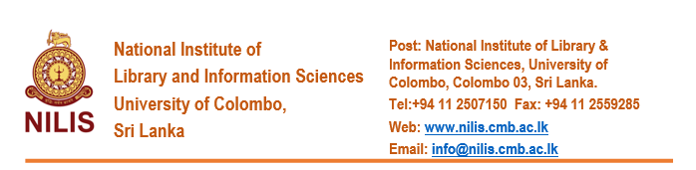
FORM OF APPLICATION
Post of Visiting Lecturers – 2022-2023

1. Name in Full: Underline Surname
2. Whether Rev./Mr./Mrs./Miss

3. Postal Address

4. Mobile Numbers & email address |  |  | Mobile |  |  |  |  |  | WhatsApp |  |  |  |  |  |  |  | email
5. Date of Birth

6. Civil Status

7. NIC Number

8. Education - Schools attended  (i).  (ii).  (iii).  (iv). |  |  | From |  |  |  |  |  | To
9. University Education - Bachelor’s degree

University |  |  | From |  | To |  |  |  | Course followed (with subjects) |  |  |  |  | Medium of study |  |  |  |  | Results (give Class or Grade)
10. Postgraduate Diplomas and Degrees

University |  | From |  | To |  |  |  |  |  | Course followed (with subjects) |  |  | Medium of Study |  |  |  |  |  |  | Results
(i)

(ii)

(iii)

(iv)

11. Professional Qualifications (Associateships Fellowships, and similar qualification)

12. Any other academic distinctions, Medals, Prizes, Awards etc. (excluding the scholarships and travel grants) Indicate the institution from which such awards have been obtained.

13. Research & Publications, if any (Please add a separate sheet if space is inadequate)

14. Experience in teaching Library & Information Science and related subjects  (Please add a separate sheet if space is inadequate) |  | Institute |  |  |  |  | Course |  |  |  |  |  |  | Subject |  |  |  |  |  |  | No. of years
15. Present Employment |  | Designation |  |  |  |  | Place |  |  |  |  |  |  | Date of first appointment
16. Subject expertise for teaching | (i)  (ii)  (iii)  (iv)
17. Language proficiency for teaching and assessment  (Please mark) | Proficiency level |  |  |  |  | Sinhala |  |  |  |  |  | Tamil |  |  |  |  |  | English
 | Proficient
 | Fair
 | Poor/No proficiency
18. Days preferred for teaching (Please mark) | Monday to Friday |  |  |  |  | Week-ends |  |  |  |  |  |  |  |  | Any day
19. Times preferred for teaching

20. Preferred mode of teaching | Online only |  |  |  |  |  |  | Face-to-face only |  |  |  |  |  |  |  | Online and face-to-face
21. Ability to visit the provincial centres (Badulla, Kandy, Kurunegala, Ratnapura etc.) to conduct classes / examinations at short notice | Yes |  |  |  |  |  |  |  |  |  | No

I hereby certify that the particulars submitted by me in this application are true and accurate. I am aware that if any of these particulars are found to be false or inaccurate, I am liable to be disqualified before selection and to be dismissed without any compensation if the inaccuracy is detected after appointment.

Signature ……………………………………………………. Date………………………..

Please post the completed form together with a Curriculum Vitae to reach on or before 28 February 2022, the Senior Asst. Registrar, National Institute of Library & Information Sciences, University of Colombo, Colombo 03.

